1. New Candidate IDs are Strings

The newly created candidate’s ID is a String and it’s not tally with the IDs of existing candidates

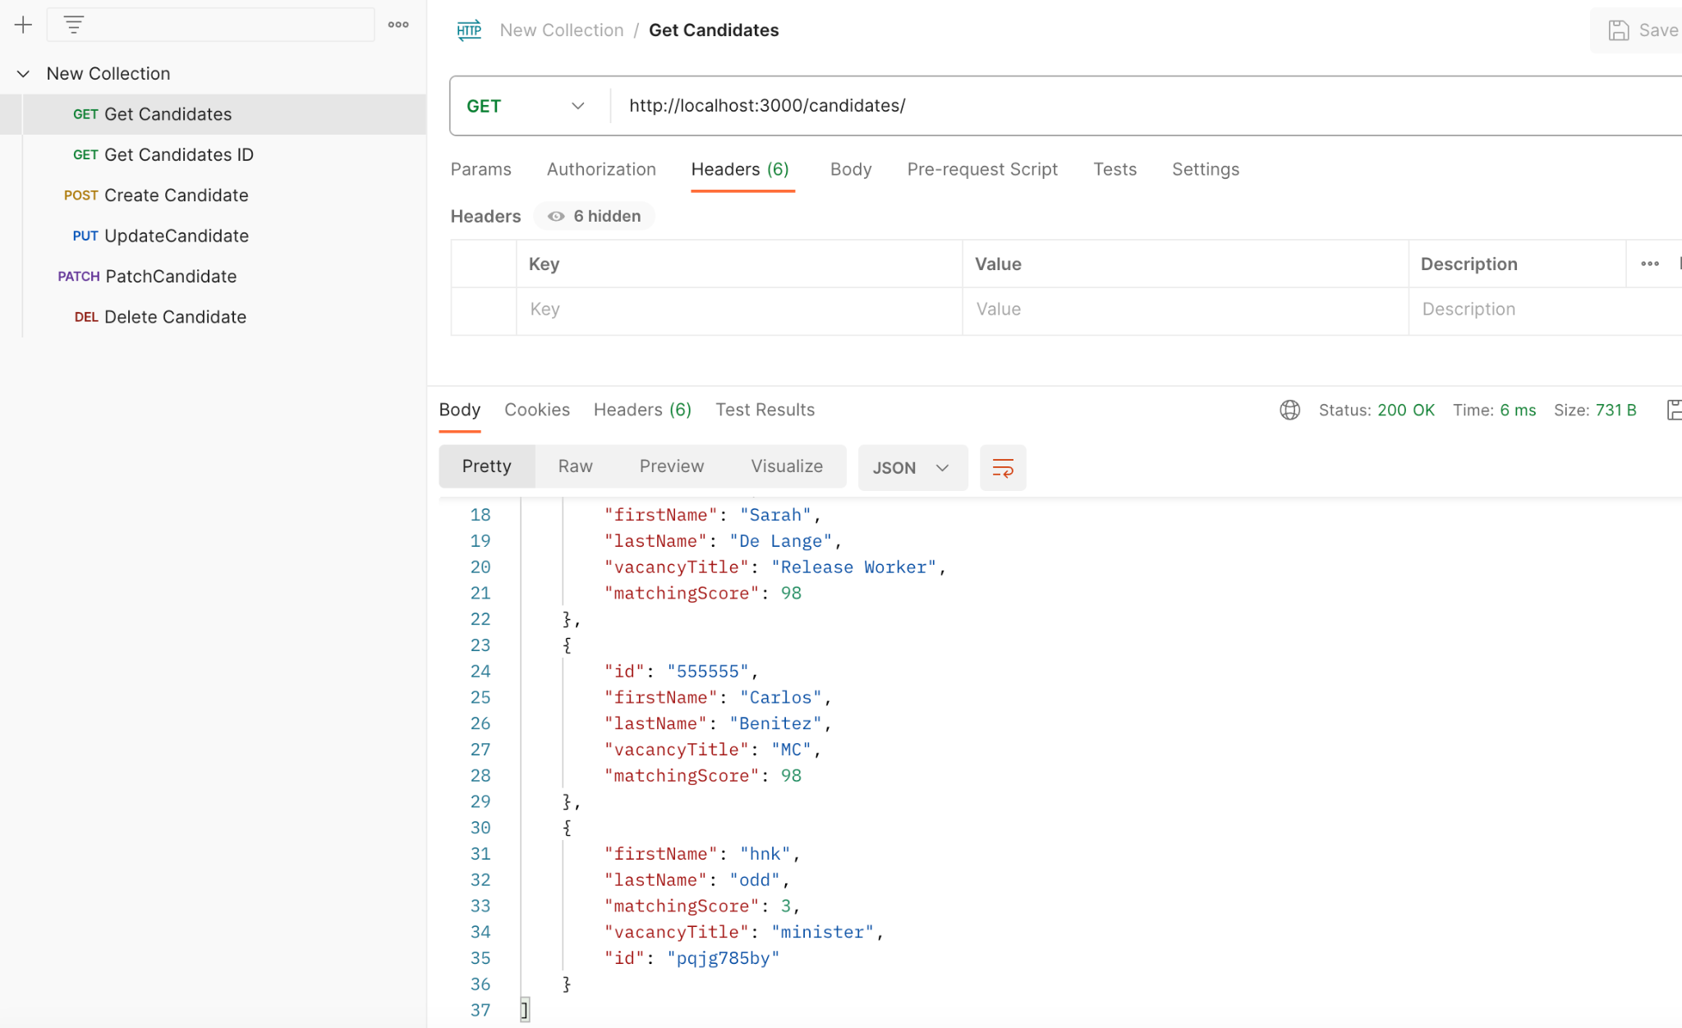

1. Incorrect response code -504

The REST API status code for not found error is 404. But ‘Get Candidates ID’ endpoint returns 504 - Gateway timeout instead.

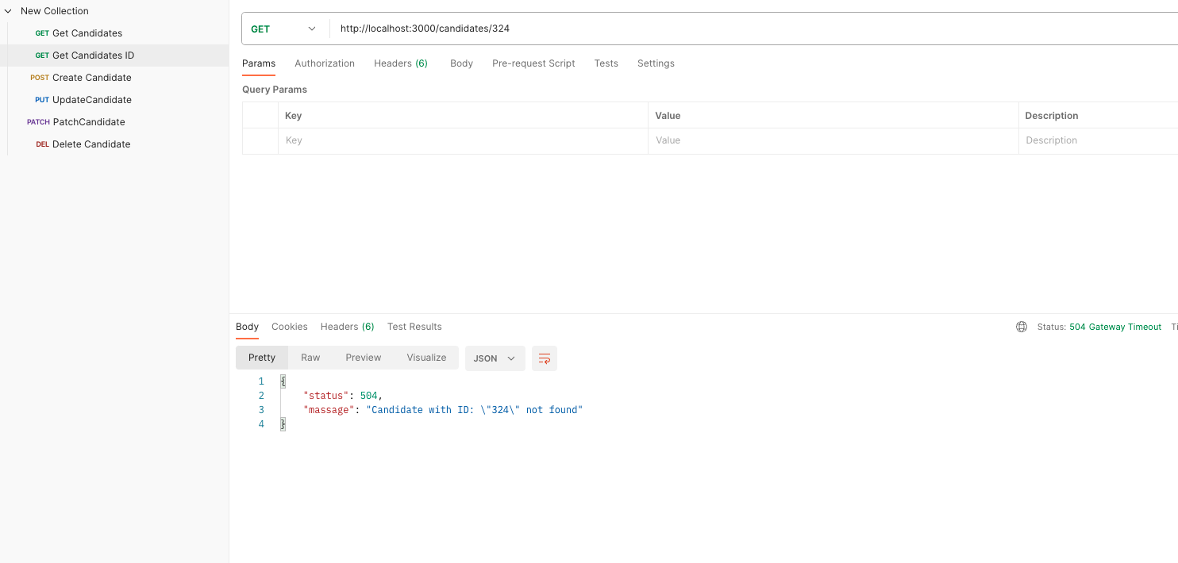

1. Candidate results are not sorted in ‘matchingScore’ in ‘Get Candidates’ endpoint

Usually results are sorted based on matchingScore but ‘Get Candidates’ endpoint results are not sorted as such.

